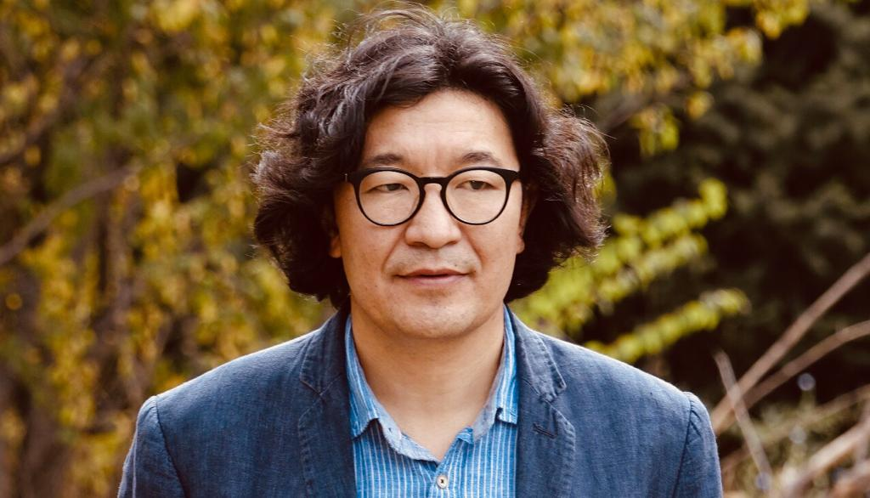
annas Bagdat
poet, playwright, screenwriter, producer

annasbagdat@gmail.com
Almaty, Kazakhstan
Education

Kazakh National Academy of Arts named after T.Zhurgenov,
Almaty 2009 – 2012

Bachelor of Film and TV studies,

Kazakh National Academy of Arts named after T.Zhurgenov Almaty 2012 -
M.A. of Film and TV studies

Kazakh National Academy of Arts named after T.Zhurgenov Almaty 2017-2020
PhD
Employment history
Senior teacher
2010 –
Department of Cinema History and Theory at Kazakh National Academy of Arts named after T.Zhurgenov

Playwright
2014 – 2019
M.Auezov Kazakh State Academic Drama Theater

Project author and editor-in-chief
2016-
Oner.kz art portal.

Ozart Production, CEO
2015-2021
Astana Musical theater, director.
2021 - 2023
ArtKöshe independent theater, founder, producer.
2022 -

Plays
Baqtan otkende (Passing the Garden), 2014
Eles janbır (Ghost rain), 2013
Ruh (Spirit), German Drama Theater, 2016
Almas qılıs (Diamond sword), Kazakh State Academic Drama Theater named after M.Auezov, 2016
Dostar serti (Friends’ Vow), Astana Musical Theatre, 2016
Er Tostik; Theatre of Astana Musical 2017
Jır-Jolbarıs (Moment of Zhambyl’s life), Alatau traditional theater of art, 2018
Shanyraq (From the cradle to the grave), Astana Musical Theatre, 2019
SEN musical, ArtKöshe independent theater, 2022
Päter 30/1, ArtKöshe independent theater, 2023
Screenplays
Ali and Aiya, Animated series - (first season, 2013-2014, balapan channel);
Aidar, animated series - (1 season 2018, 2-3 season 2019, balapan channel);
Ak kus (White bird) TV-series - (2018, balapan channel);
Syilyq (Present) author of the short film (2018, balapan channel);
Altyn adam (Golden man), Full-feature animated film (Kazakhfilm, 2020).
Director
Aidar, animated series - (1 season 2018, 2-3 season 2019, balapan channel);
Päter 30/1, ArtKöshe independent theater, 2023
Producer
Aidar, animated series - (1 season 2018, 2-3 season 2019, balapan channel);
SEN, musical, ArtKöshe independent theater, 2022
Päter 30/1, ArtKöshe independent theater, 2023
Awards
Winner of the nomination "The best drama of the year" of the literary prize "Altyn tobylgy", created by the Foundation of the First President of the Republic of Kazakhstan (2015 for the play "Baqtan otkende" ‘Passing the Garden’).
"The playwright of the Year" (2016). Professional award “Enlikgul – 2016” created by The Union of Theatrical Figures of Kazakhstan.

