Temirbek Zhurgenov Kazakh National Academy of Arts
Faculty of «Choreography»

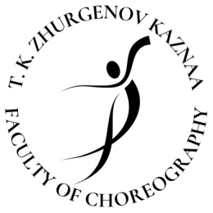

APPLICATION FOR PARTICIPATION IN
V YOUTH CHOREOGRAPH COMPETITION
«ULY DALA JASTARY 2023»

1 | Full name
2 | Date and place of birth
3 | The name of the educational institution where the contestant is studying
4 | Group, course
5 | Address of residence
6 | Phone number
7 | E-mail
8 | Instagram | @
9 | Choreographic composition submitted for the competition (composer, name, direction of dance)
10 | Duration
11 | Link to the video of the dance presented at the competition
12 | What specialty do you plan to enter (pedagogy of choreography, pedagogy of modern choreography, pedagogy of sports ballroom dancing, art of ballet master)?

Date

Full name signature

- The completed application is signed on the computer by hand and two application files are sent to the specified e-mail address: Word and a scanned copy in PDF format

