Republican state enterprise
“Temirbek Zhurgenov Kazakh National Academy of Arts”
Ministry of Art and Sport of the Republic of Kazakhstan

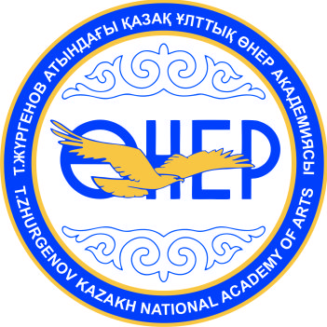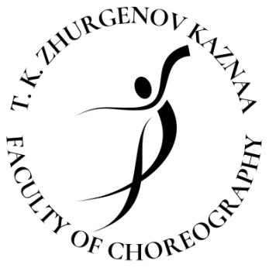

REGULATION
OF THE V YOUTH COMPETITION OF CHOREOGRAPHERS
«ULY DALA JASTARY»

January 12th, 2023

Format of the competition is offline

1. General terms

1. 1. Youth competition of choreographers created by choreography faculty of the Temirbek Zhurgenov Kazakh National Academy of Arts in order to muster potential applicants. Winners of the competition — laureates of 1 degree — join Temirbek Zhurgenov Kazakh National Academy of Arts without passing creative examination.

1. 2. Goals of the competition:
— including all participants to the list of potential university entrants;
— support and development of creative potential of young choreographers and teachers;
— popularization of the choreographic art in Kazakhstan, development of dance directions, sharing experiences and knowledge in choreography;
— talent identification.
1. 3. An Arrangements committee is formed to conduct the competition, list of members is approved by order from the rector of Temirbek Zhurgenov Kazakh National Academy of Arts and consists of High-education teaching personnel of choreography faculty.
1. 4. An Arrangements committee approves members of jury, president of jury and a secretary of the competition.

2. Competition conditions

2. 1. Potential applicants from all over the Republic of Kazakhstan can participate in the competition.
2. 2. Application form is processed by Arrangements committee.
2. 3. All participants must fill the application form fully and correctly. Repertory for competition cannot be changed during the Competition.
2. 4. An application form signed by the ones who wish to participate in the competition is confirmation that applicant fully understands rules and conditions of the competition.
2. 5. Participants of the competition pass 2 rounds:
1st round:
Classical dance training (practical demonstration of movements at the barre and in the middle of the room, allegro section)
2nd round:
— applicants for admission to specialization “Choreographic art” show one solo choreographic work in an author's production lasting no more than 3 minutes.. Dance must be new, created for competition. Music and style of work are at the will of a participant (classical dance, neoclassical dance, folk-stage dance, modern choreography contemporary and modern).
— all those who wish to study on “Pedagogy of Choreography”, “Pedagogy of Sport Ballroom Dance”, “Pedagogy of Modern Choreography” specializations present solo dance lasting no more than 3 minutes. Music, choreography and style of dance are at the will of a participant.
2. 6. All needed stage property and costumes for participation in the competition are provided by participants of the competition. An Arrangements committee does not provide stage property, scene costumes, make up and shoes for participants of the Competition.
2. 7. In order to avoid technical problems participants of the competition must provide music on the USB and send it to faculty email address kaznai_ulydalajastary@mail.ru with subject of the letter “Application form and music for choreography competition 2023” in MP3 format.
2. 8. An Arrangements committee does not provide ballet classes and a concertmaster.
2. 9. Participants of the competition will have one rehearsal in the ballet class at the day of the competition (time for rehearsal is no more than 10 minutes).
2. 10. An Arrangements committee does not provide any types of insurance for participants of the Competition and their group.
2. 11. An Arrangements committee retains the right to broadcast performances of participants and their compositions on the TV, Internet, social networks, record video filming, on video media and their further distribution without paying a fee to the participants of the competition, their performers.
2. 12. Video or filming by all persons without exception (performances of participants) is possible only with special permission (accreditation) of the Arrangements committee.

3. Policy for the competition

3. 1. Order for presenting/showing entry is established by Arrangements committee.
3. 2. Competitive trials consist of two rounds: first round, a break, second round, discussion, announcement of results. View of the competition numbers of the 2nd round is held publicly.
3. 3. Each competitive work and performing skill of the first round is evaluated by the jury individually according to a 10-point system and is recorded in the corresponding bulletin.
3. 4. The jury evaluates the entries according to the following criteria:

1 ROUND

“CLASSICAL DANCE TRAINING”
1) Literacy performance;
2) Musical performance;
3) Coordination of movement.
2 ROUND

“CHOREOGRAPHY ART”
1) Artistic expressiveness of images;
2) Development of movements and combinations;
3) The compositional integrity of the number;
4) Musical-choreographic drama;
5) Performing skills.

“PEDAGOGY OF CHOREOGRAPHY”,
“PEDAGOGY OF SPORT BALLROOM DANCE”,
“PEDAGOGY OF MODERN CHOREOGRAPHY”
1) Artistic expressiveness of images;
2) Literacy performance;
3) Musicality and coordination.

3. 5. Decision of the Jury is made under calculation of scored points. Results of the Competition will be formed under following report.
3. 6. The results of the competition are announced to the participants on the day of the competition.

4. The jury working procedure and awarding the winners of the competition

4. 1. The performance of participants is evaluated by a professional jury, which includes High-education teaching personnel of choreography faculty of Temirbek Zhurgenov Kazakh National Academy of Arts.
4. 2. Members of jury and a secretary are present at all performances, included in the Competition program, and in all meetings.
4. 3. A chairman of the competition is an invited figure of choreographic art.
4. 4. After each performance, the jury members enter corresponding points in the bulletin and hand them over to the secretary for counting the votes.
4. 5. Jury members award prizes in the following categories:
— Laureate of I, II, III degree;
— Diploma winner.
4. 6. Winners of competition - laureates of 1 degree — join Temirbek Zhurgenov Kazakh National Academy of Arts (with results of Unified National Testing) without passing creative examination.
4. 7. Authors of the best works, which will be presented on the competition, will get recommendations and entry-pass from the faculty of choreography and academy to enter Temirbek Zhurgenov Kazakh National Academy of Arts.
4. 8. The decision of the jury is final and not subject to revision.

Application forms and all related materials need to be presented to the Arrangements committee before January 8th, 2023 (inclusively). All applications forms received after this date — whatever the reason — will not be considered and will not participate in the competition.

Address of the Arrangements committee: 050000; Almaty, 127, Panfilov str, Temirbek Zhurgenov Kazakh National Academy of Arts, faculty of the choreography.
For additional information:
Email: kaznai_ulydalajastary@mail.ru
Call-centre: +7 707 839 6157 (Isaliyev Alibek Temizhanovich)

